12.36: a) 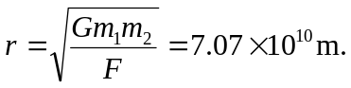

b) From Eq. (12.19), using the result of part (a),
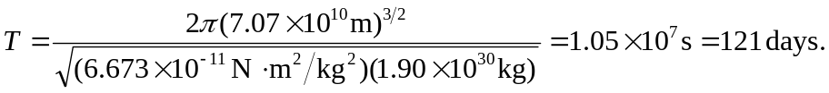

c) From Eq. (12.14) the radius is 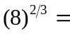 four times that of the large planet’s orbit, or 